1. Server time at R-73

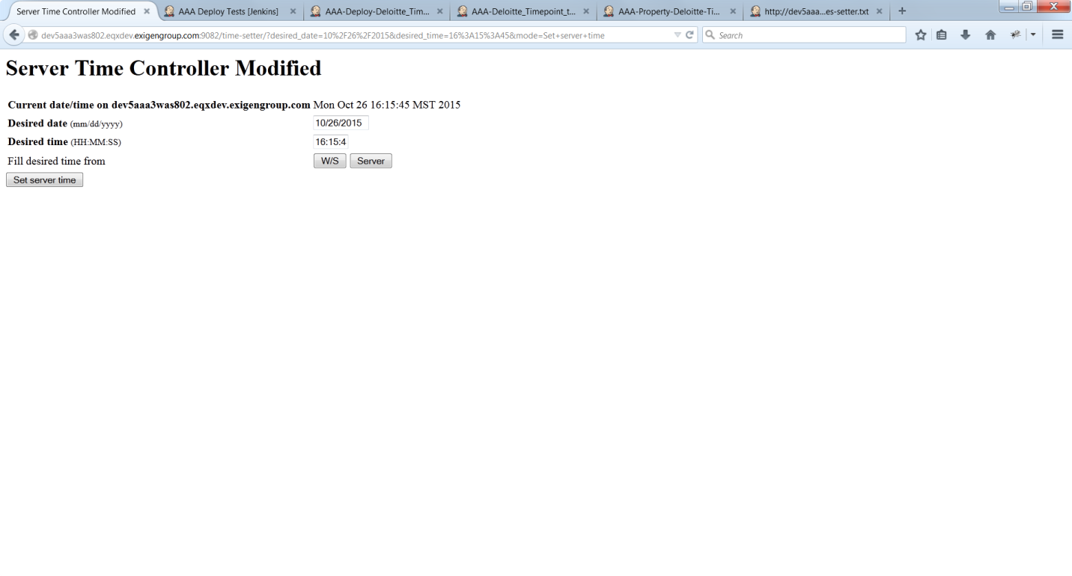

1. Jobs ran

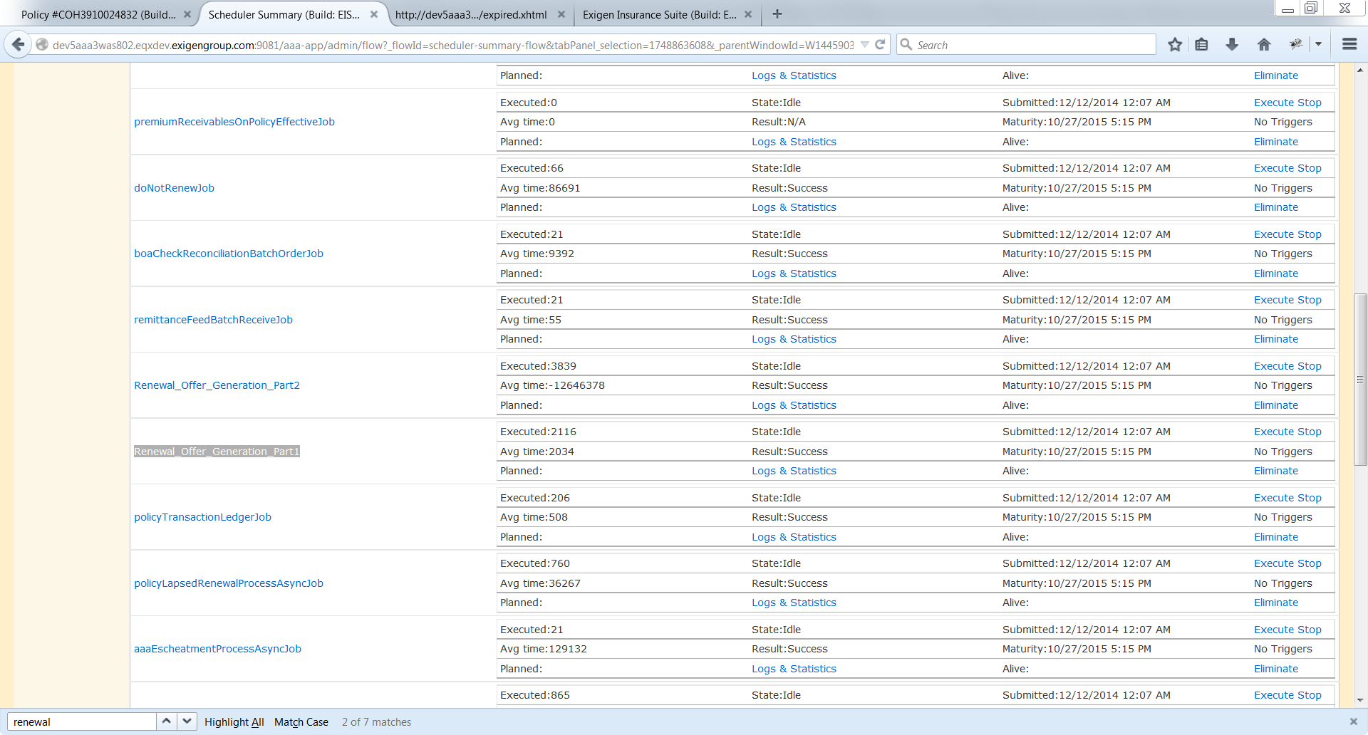

1. Renewal link is still disabled.

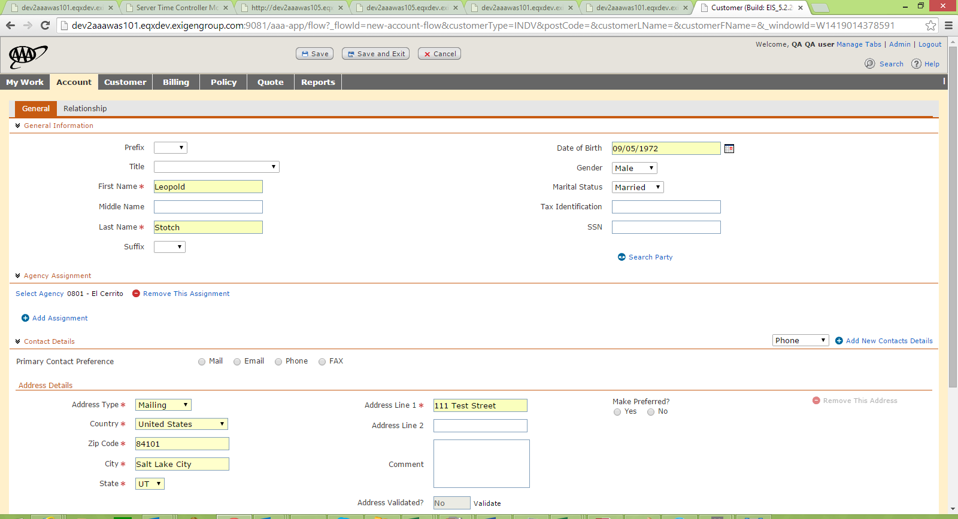

1. User logins and creates an account for UT state.

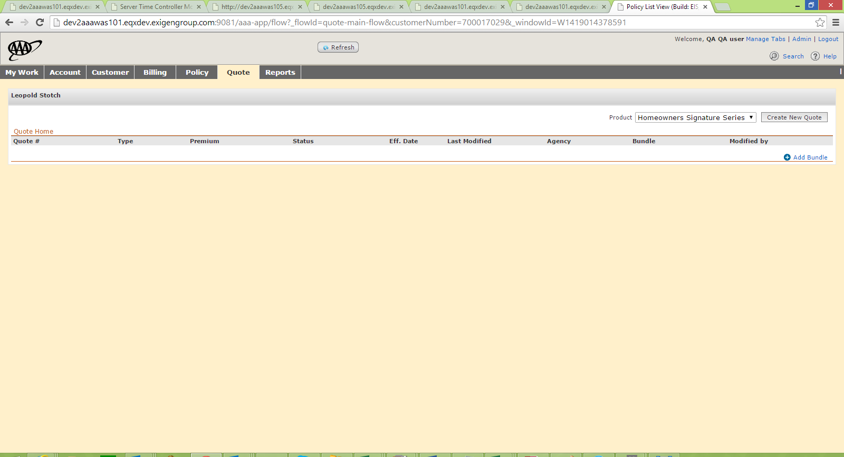

1. User selects Home Owners Signatures Series.

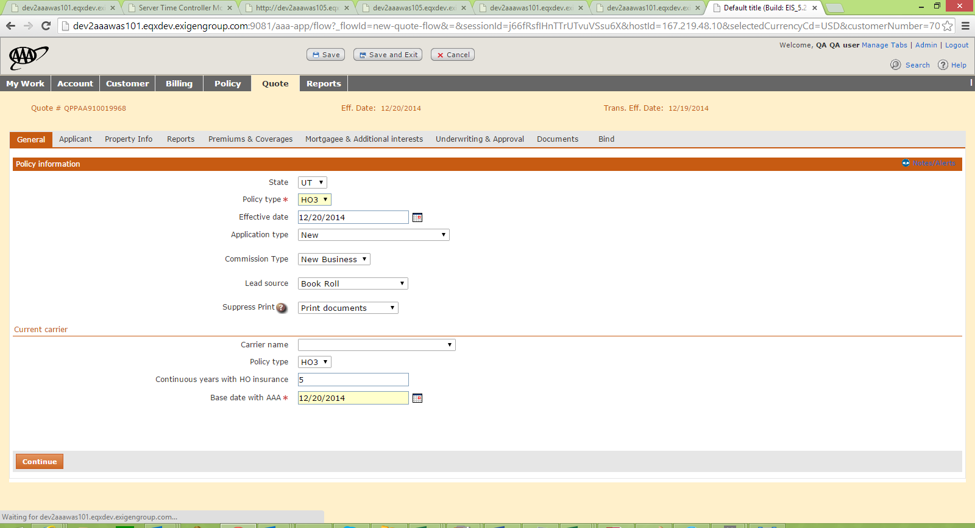

1. User navigates to General Page and enters the mandatory details.

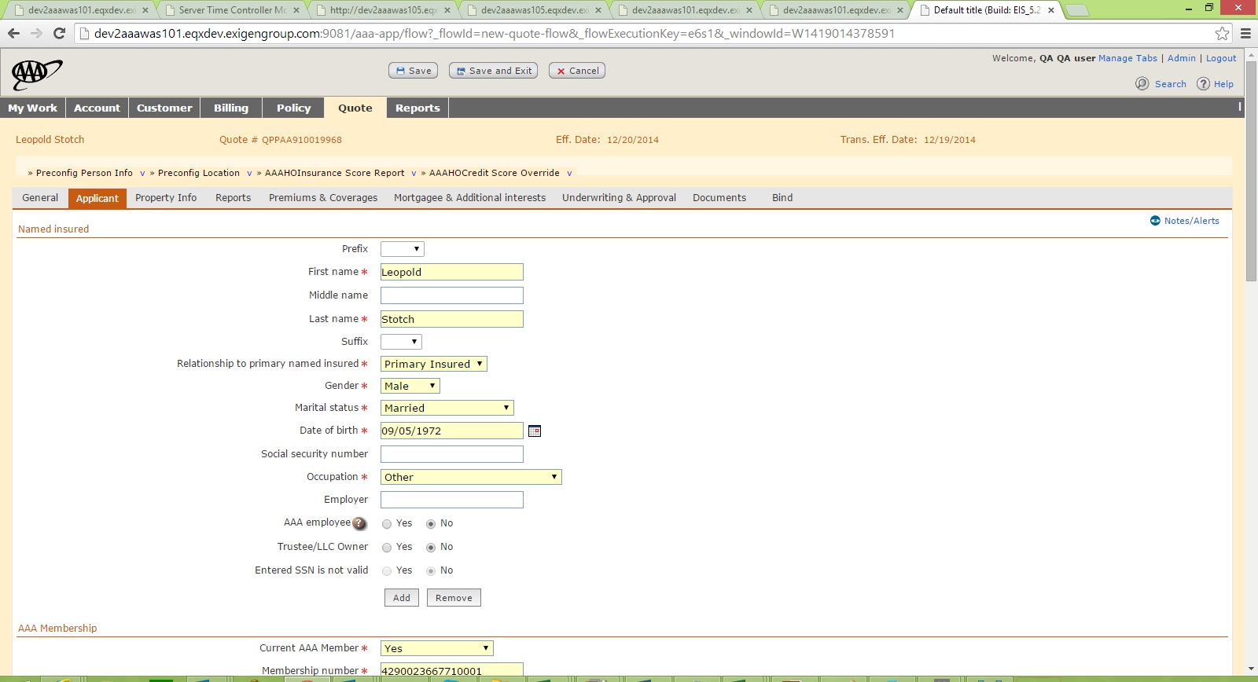

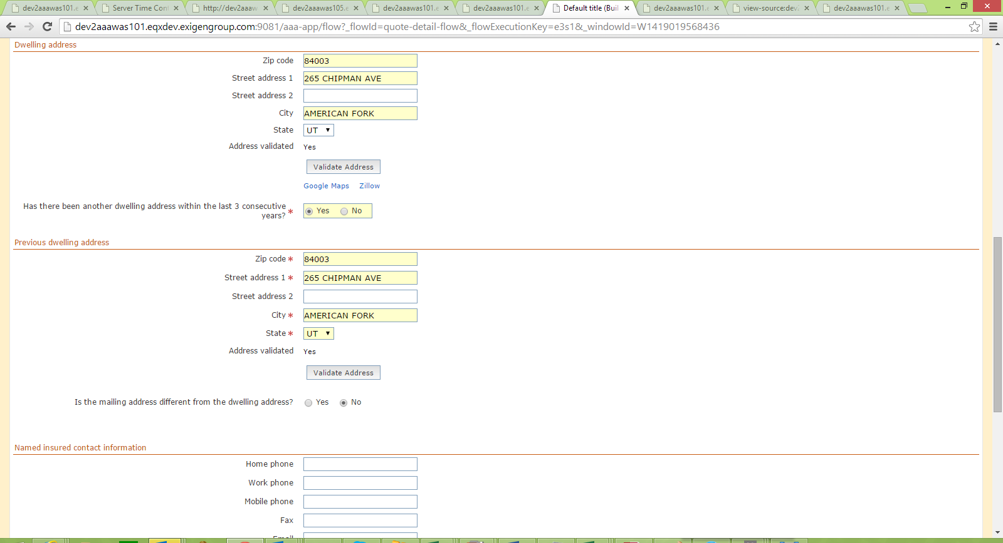

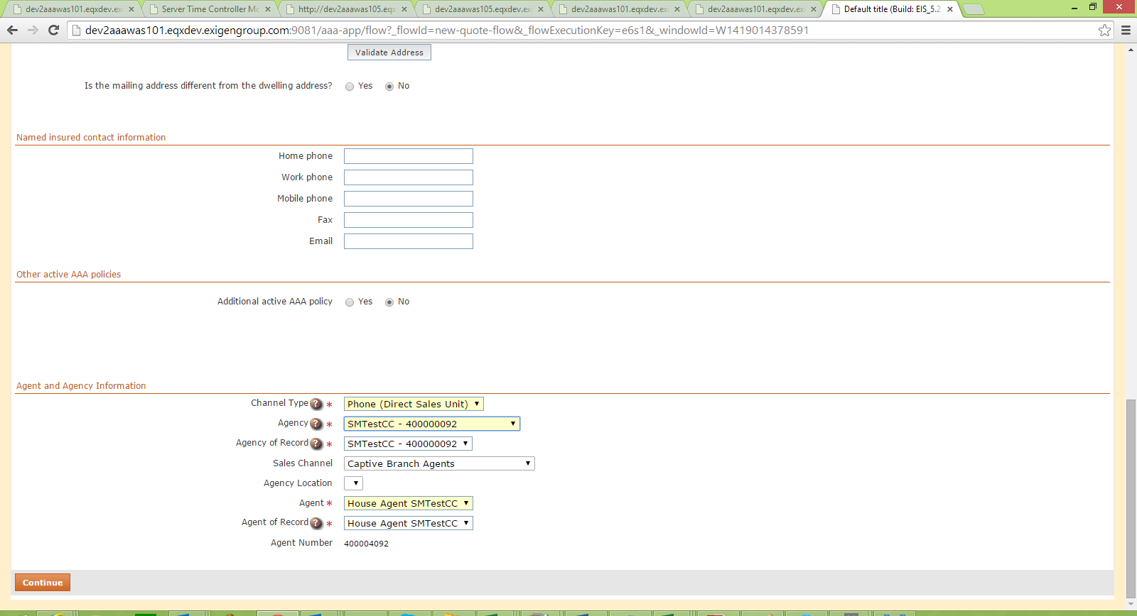

1. User enters the required details and selects YES for “Has there been any other dwelling address in the last 3 consecutive years?”

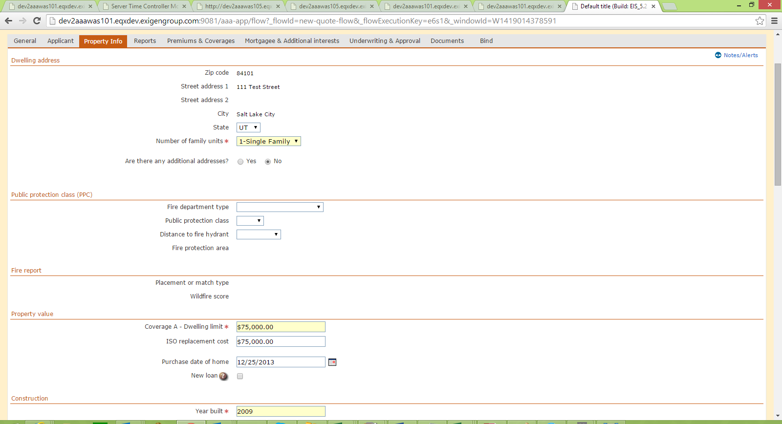

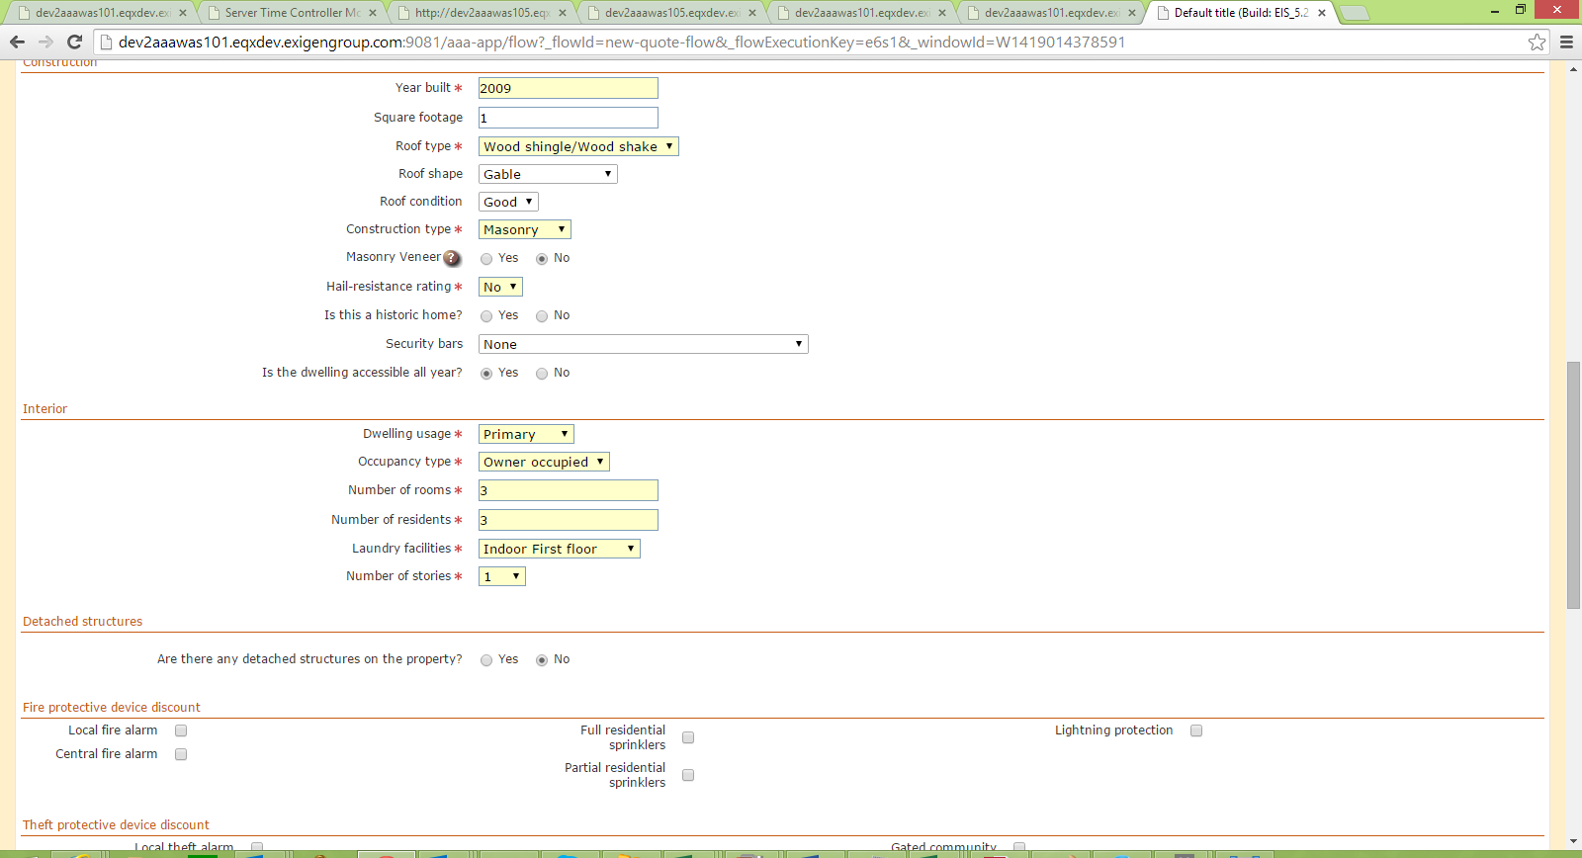

1. User enters the mandatory details in the property info tab.

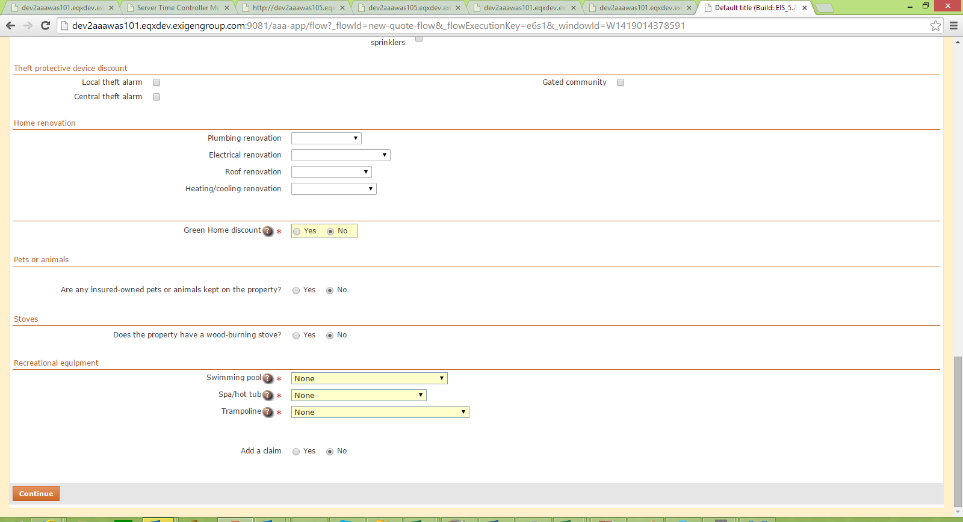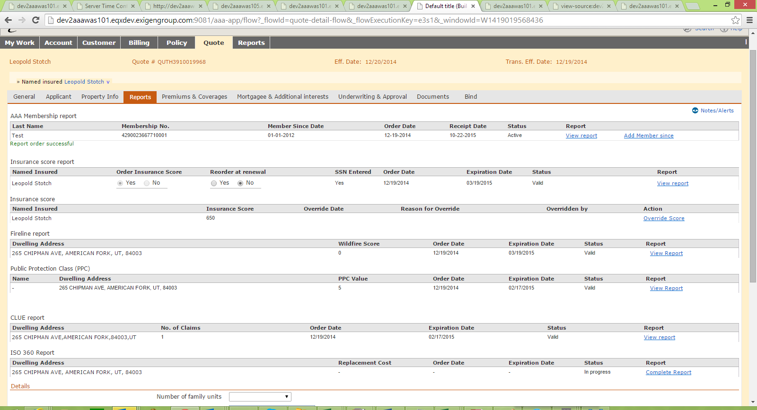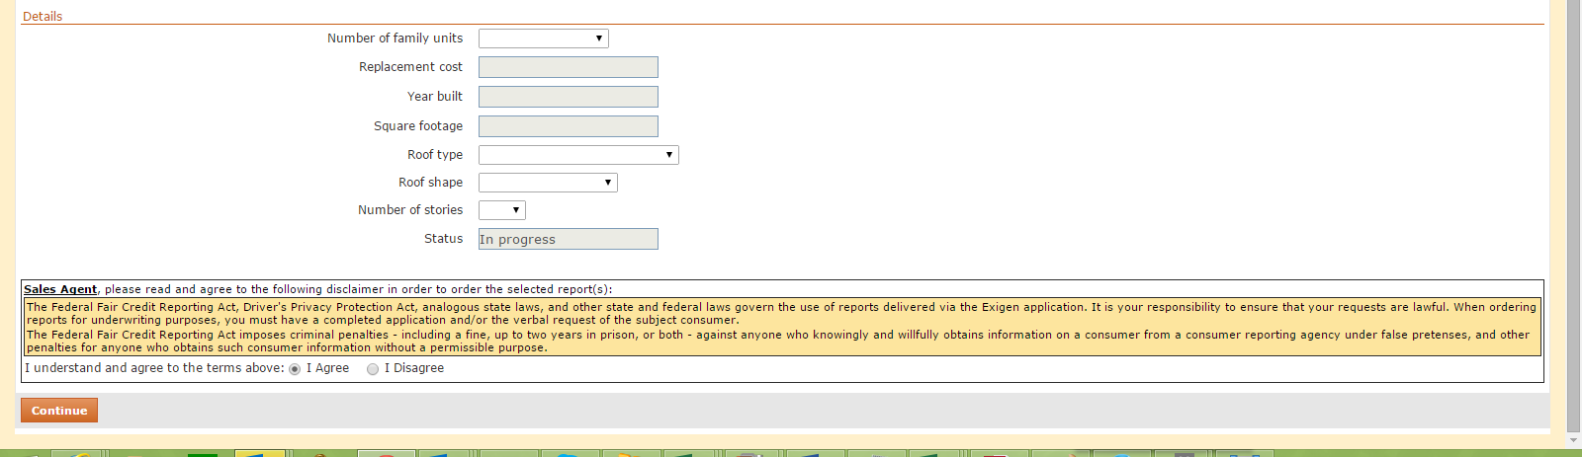

1. In the Reports page, user validates the insurance score report fields and orders the reports.
2. User clicks on the View Report Link in the insurance Score Section.

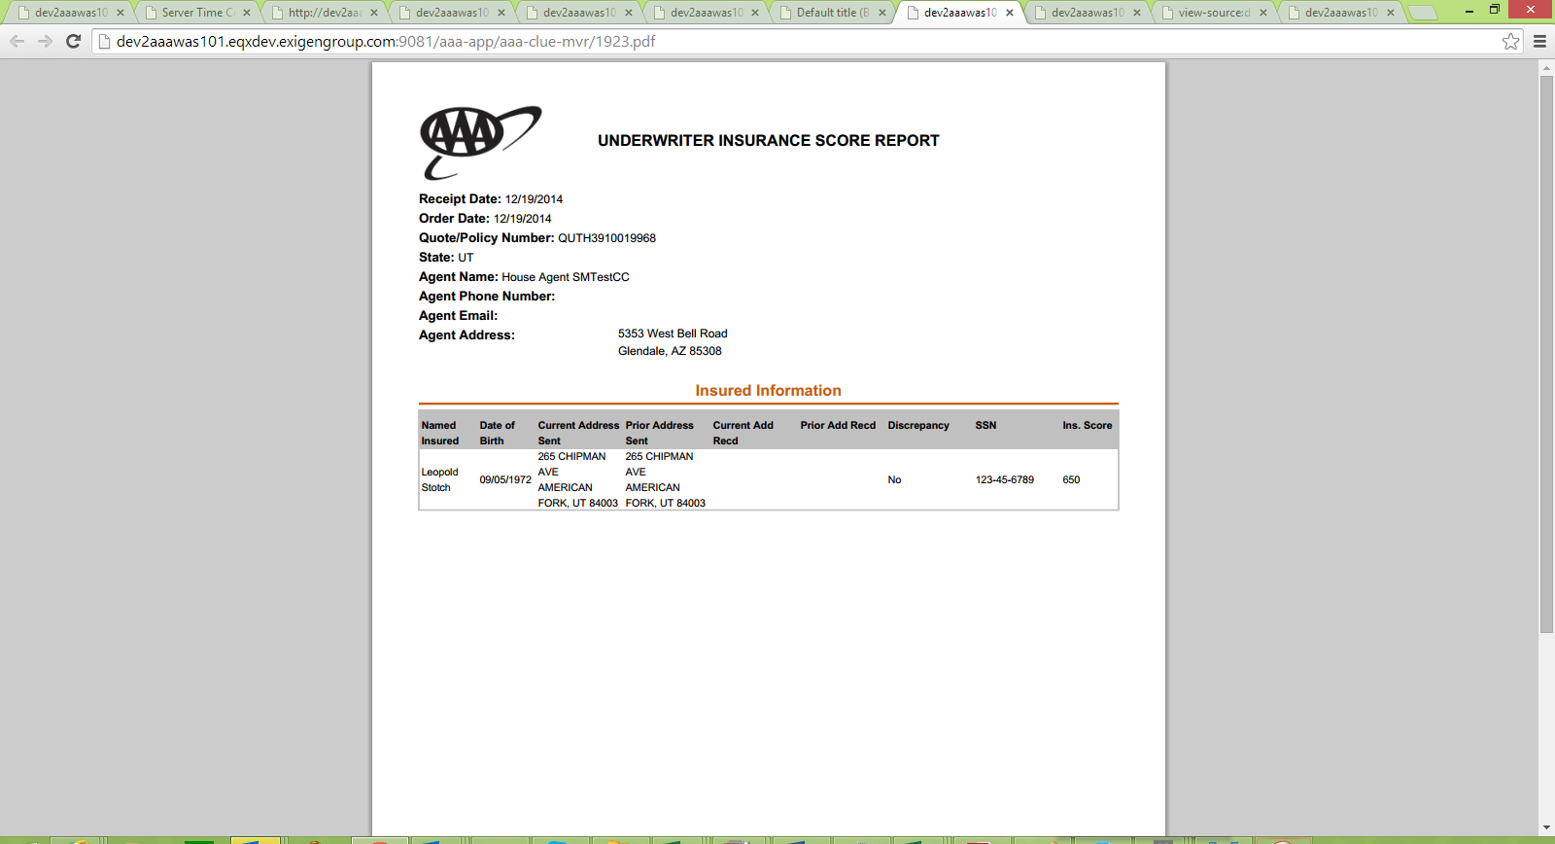

1. The report opens in a pdf format.

The user then navigates to the E-Folder.

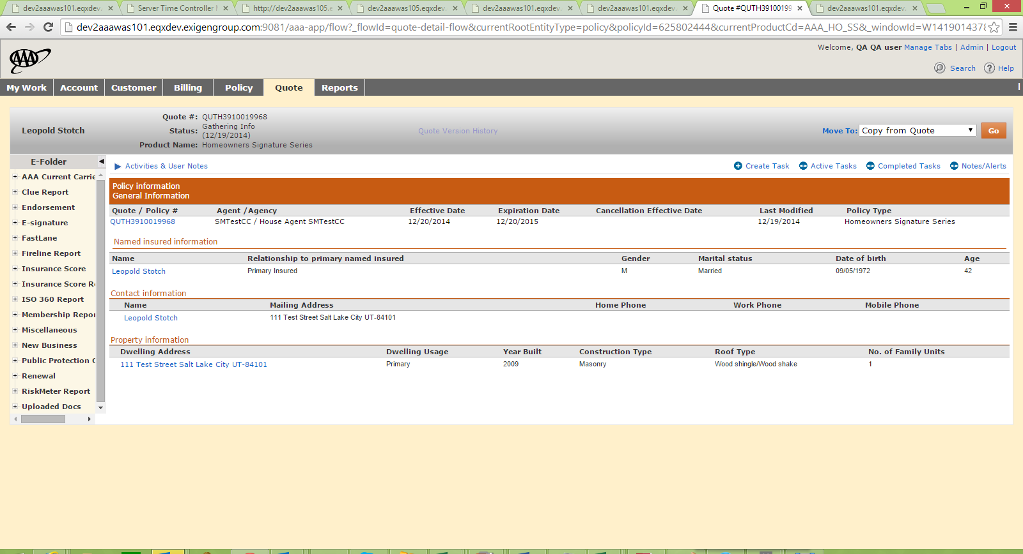

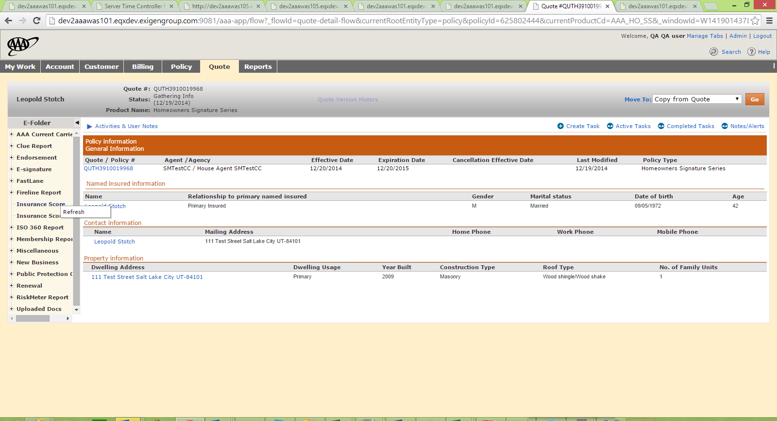

EXPECTED RESULT: Agent navigates to E-folder and validates whether the latest Agent Insurance Score Report is displayed under the 'Insurance Score' folder. The insurance score report should be present in the E-Folder.

ACTUAL RESULT: The insurance score report is not present in the Insurance Score folder as expected.